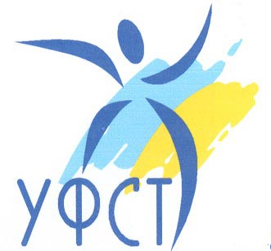
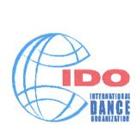
Official document
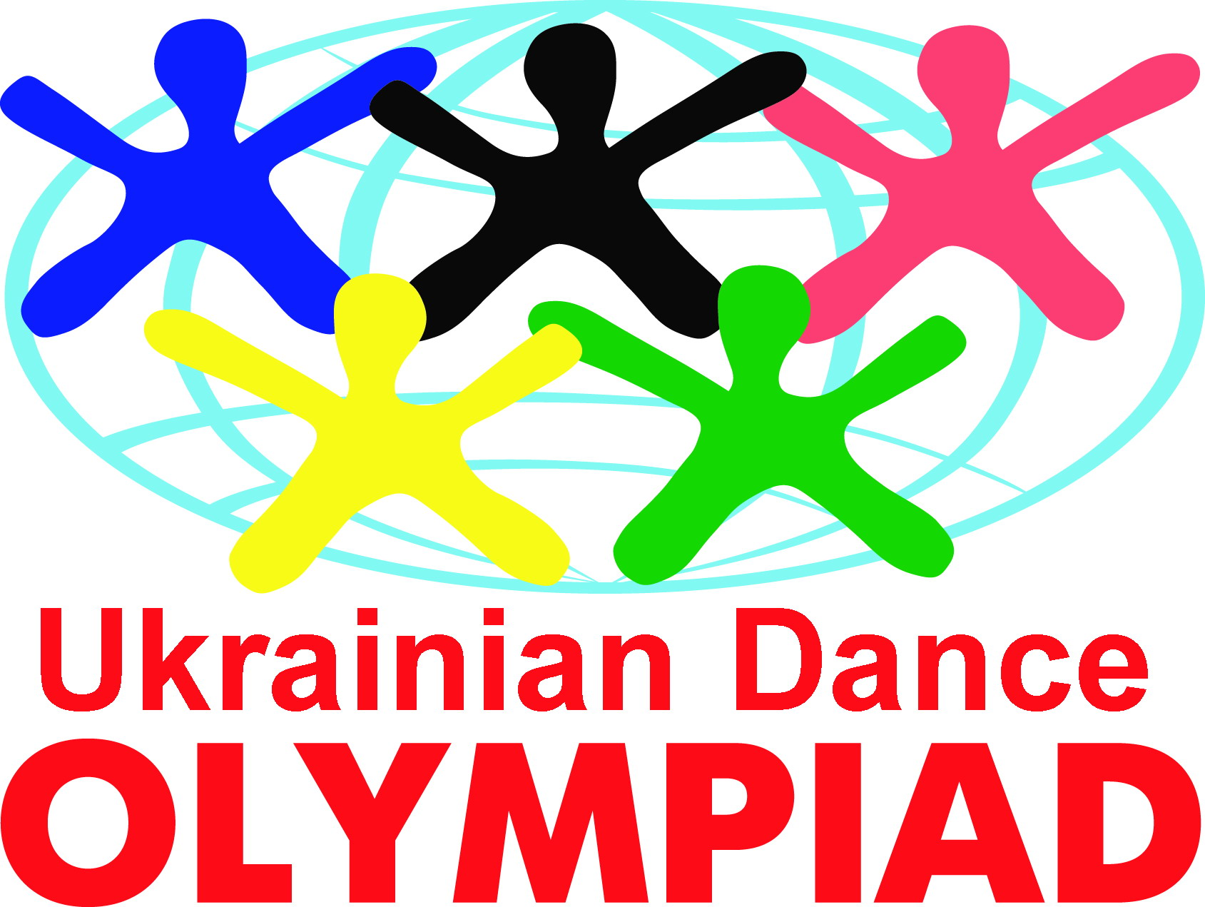

International Dance Organization
UKRAINIAN MODERN DANCE FEDERATION
WORLD DANCE OLYMPIAD COMMITTEE
Centre of dancing development «EURODANCE»
Invites for the Official IDO event in Ukraine
Open to the World – IDO
III-UKRAINIAN DANCE OLYMPIAD (UDO)
III – Ukrainian dance Olympiad is a unique and grandiose event for our country because only last year it gathered nearly 120 dance teams. That is 2500 dancers from Ukraine, Russia, Moldova, Belarus, Armenia and Israel. This year UDO expects for 10 countries 250 dance teams and 4500 participants.
III - Ukrainian dance Olympiad will last in Ukraine Ternopil city during 4 days.
November, 28th – the 8th Open Ukrainian UMDF Championship and leagues rating in
Hip–hop, break–dance, electric, popping, crump
November, 29th – the 7th Open Ukrainian UMDF Cup and leagues rating in
Disco dance, techno, house dance, tectonic
November, 30th – the 4th Open Ukrainian UMDF Cup and leagues rating Belly-Dance (classic, folk, show)
December, 1st - the 7th Open Ukrainian UMDF Cup and Festival-Competition in dance show, twirling, majorette, street-dance show, jazz, ballet, modern dance, step, salsa, Argentina tango, flamenco, folk, Indian dances
IDO judges from Ukraine, Russia, Moldova, Belarus, Armenia and Latvia. The competitions last due to the IDO rules.
Dance nominations: solo, duos, small groups (3-7 dancers), formation (8-24 dancers), production (more than 24 dancers) battles for solo and team dancers in hip-hop, break –dance, popping.
Program includes rating competitions for leagues (beginners, second and first leagues)
Among the following age categories: children ( to 7 years, 8-11 years), juniors (12 – 15 years), adults (16-35 years) and seniors (36 years and older)
Financial conditions
Solo - one nomination – 10 euro
Duos - one nomination – 10 euro
Small groups- one nomination – 30 euro
Formation – one nomination – 60 euro
Production – one nomination – 80 euro
Entry fee for spectators for one day - 5 euro

Registration will last the one day before competition day in each discipline in the Olympiad’s organization centre from 12.00 till 20.00. Each participant during the registration must have badge and certificate of the Olympiad’s participant.
The winners rewarding are diplomas cups and medals.

All the needed information about your accommodation you can get calling «EURODANCE» office:
(Ternopil city, Klyma Savyru street, 1) tel. +38 (0352) 42-35-35, +38(067)350-49-00,
e-mail us: style2003@rambler.ru www.umdf.com.ua

Preliminary applications for the participation – on-line on www.regumdf.org.ua and neccessary on UMDF e-mail info@umdf.com.ua and on the organization’s one: style2003@rambler.ru
The applications will be accepted till November, 14th

The organizers and foundations of the Ukrainian Dance Olympiad:

UMDF President Pavel Boyko

«EURODANCE» President Svitlana Girchack

