STOD IDO 20 year’s celebration.
It is a great pleasure to congratulate the STOD IDO to it’s 20 year celebration. During my time as the President of the IDO one could always rely on the Slovak team of dancers. They were always loyal to the IDO and did travel around the world in order to participate at IDO-events in spite that they have to travel far away. If we organized a Mambo World Championship in America it was Slovak couples there. If we organized Salsa or Argentine tango Championships in Hong Kong we had Slovak dancers taking part. I found in my files some photos from Hong Kong and this is the Slovak Champion in Salsa.
I also want give a special thanks to Hana Svehlova who playe a very important part in the reconstruction of the IDO when I Chaired the reconstruction committee in connection with Mr. Polidory leaving the IDO and the reconstruction committee was taking over. Hana had a special eye for rules and regulations and could spot a spelling mistake miles away. Thank you Hana.
Once again CONGRATULATIONS!
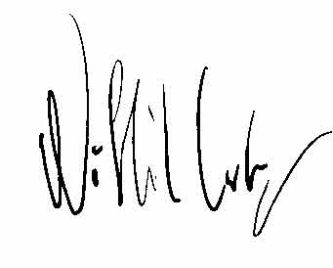
Nils-Håkan Carlzon
IDO Honorary Life time President

